**Hacked changes to simplify the Solr example Solritas UI**  
<http://localhost:8983/solr/collection1/browse?q>=

**Before:**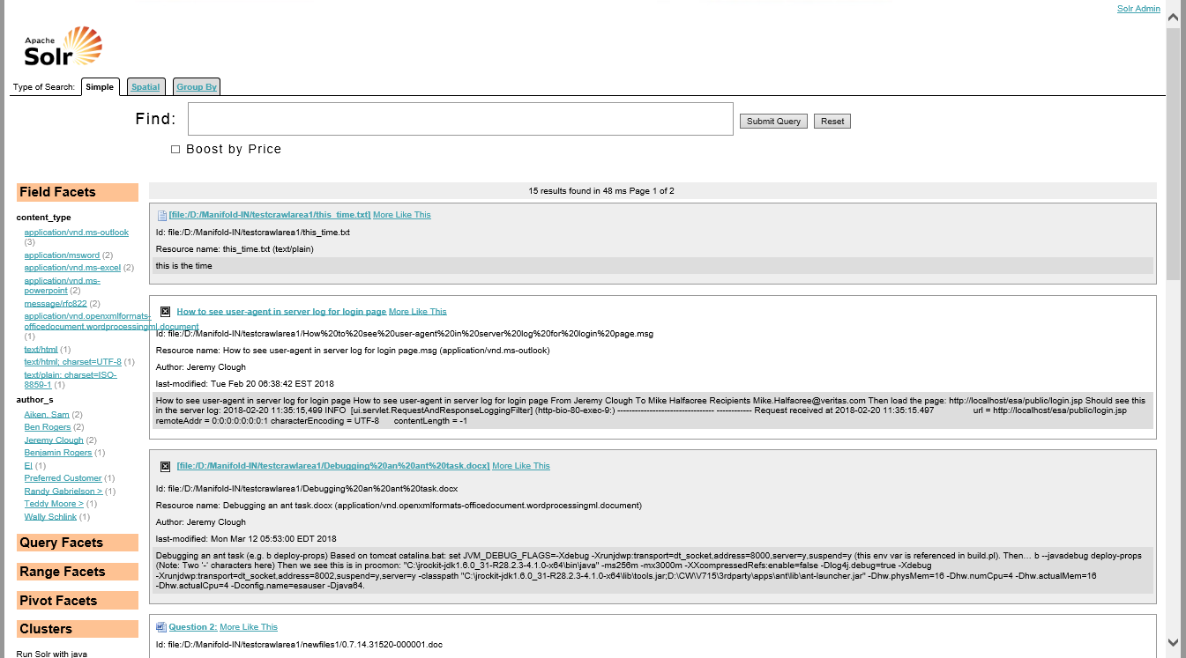  
  
**After simplification (with the hacked changes):**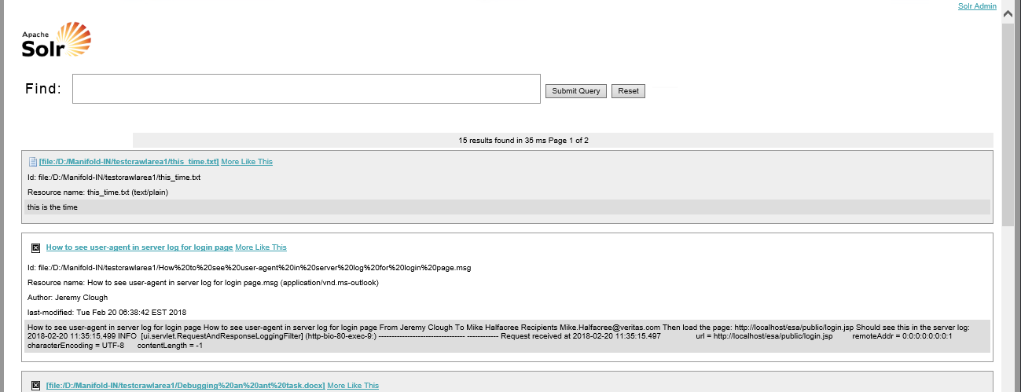

Here are the hacked changes…  
  
(Note: No need to restart Solr after making each change – just reload the Solritras page).

**1) Remove the tabs at the top of the page:**

|  |
| --- |
| Replace “example/solr/collection1/conf/velocity/**tabs.vm**” with an empty file. |

**2) Remove the footer:**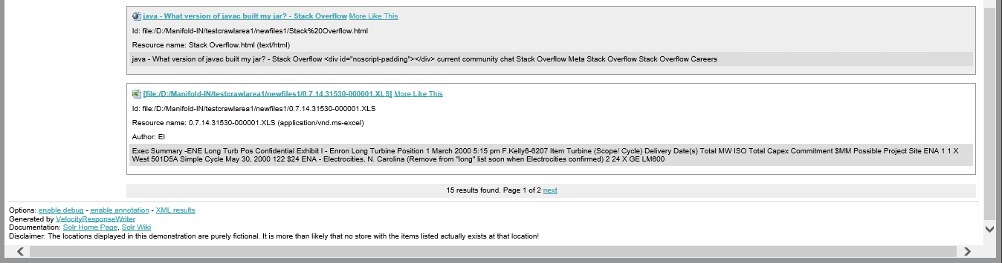

|  |
| --- |
| Replace “example/solr/collection1/conf/velocity/**footer.vm**” with an empty file. |

**3) Remove “Field Facets, Query Facets, Range, Facets, Pivot Facets, Clusters” from left column.**

|  |
| --- |
| Replace “example/solr/collection1/conf/velocity/**facets.vm**” with an empty file. |

**Note:** This does not remove the column – effectively leaving an indent on the left hand side:  
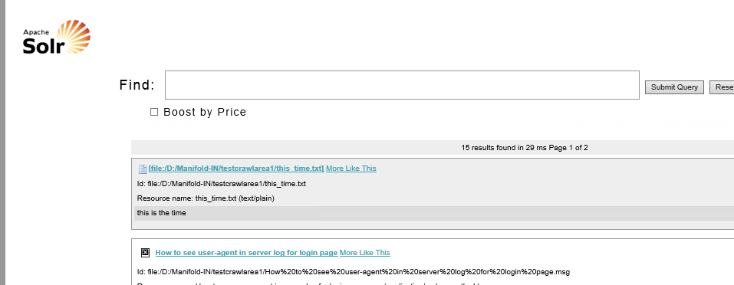

**4) Remove the indent on the left-hand-side (for the search both, and results below it).**

|  |
| --- |
| $ diff -c example/solr/collection1/conf/velocity/**main.css**.orig example/solr/collection1/conf/velocity/main.css  *** example/solr/collection1/conf/velocity/main.css.orig 2018-06-04 10:56:07.870314900 -0400  --- example/solr/collection1/conf/velocity/main.css 2018-06-04 11:12:54.451356600 -0400  ***************  *** 154,160 ****  }  .query-box .inputs{  ! left: 180px;  position: relative;  }  --- 154,160 ----  }  .query-box .inputs{  ! left: 18px;  position: relative;  }  ***************  *** 177,183 ****  border: 1px solid #999;  padding: 5px;  margin: 5px;  ! margin-left: 210px;  margin-bottom: 15px;  }  --- 177,183 ----  border: 1px solid #999;  padding: 5px;  margin: 5px;  ! margin-left: 21px;  margin-bottom: 15px;  } |

**5) Remove the “Boot by Price” checkbox.**  


|  |
| --- |
| $ diff -c example/solr/collection1/conf/velocity/**query_form.vm**.orig example/solr/collection1/conf/velocity/query_form.vm  *** example/solr/collection1/conf/velocity/query_form.vm.orig 2018-06-05 03:49:55.503521900 -0400  --- example/solr/collection1/conf/velocity/query_form.vm 2018-06-05 03:50:17.808082300 -0400  ***************  *** 12,28 ****  <input type="submit" id="querySubmit"/>  <input type="reset"/>  </span>  - <div class="query-boost">  - <span #annTitle("Add the boost function &bf=price to the query")>  - <input type="checkbox" name="bf" value="price"  - #if($request.params.get('bf') == 'price')checked="true"#end  - >  - Boost by Price  - </input>  - </span>  - #parse("query_spatial.vm")  - #parse("query_group.vm")  - </div>  </div>  #if($request.params.get('debugQuery'))  --- 12,17 ---- |

**---  
  
  
Note:** Field searches are still possible in Solritas, e.g.:  
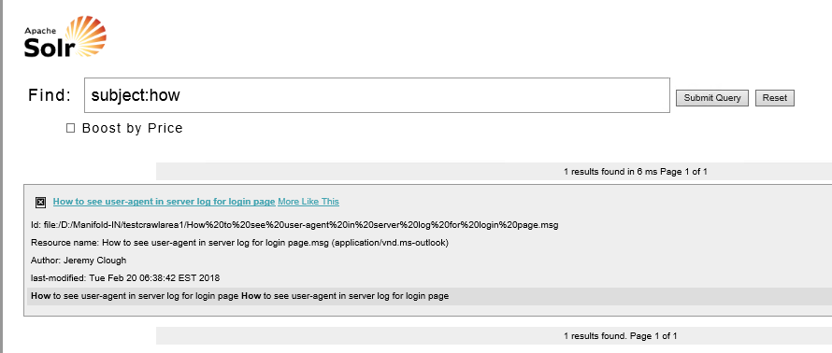  
  
  
Use the Solr admin UI to see the fields names (of the stored fields, e.g. “subject”):  
<http://localhost:8983/solr/#/collection1/query>  
  
  
Use the Luke view to see the the non-stored field names (e.g. “text”):  
<http://localhost:8983/solr/admin/luke>  
**Note:** To configure this Luke UI, add the following to “example/solr/collection1/conf/solrconfig.xml”:

|  |
| --- |
| <requestHandler name="/admin/luke" class="org.apache.solr.handler.admin.LukeRequestHandler" /> |

*JeremyC 4-06-2018***END**